User’s guide:
UKM_CASE: Release or Reject Blocked Sales orders

Contents
1. General info 3
2. SAP menu 4
3. Confirm the Sales order: 3 cases 5
3.1 General info 5
3.2 Case 1: Release the Sales order 5
3.3 Case 2: Reject the Sales order 8
3.4 Case 3: fix the issues and check Sales order after that 12

General info
Documented Credit Decisions (DCD) is a document created automatically when Sales Order (SO) gets blocked due to failed credit check. DCD is used for making a credit decision: blocked SO release or reject.
Once the credit representative releases the sales order, a delivery can be created, and a billing document generated.
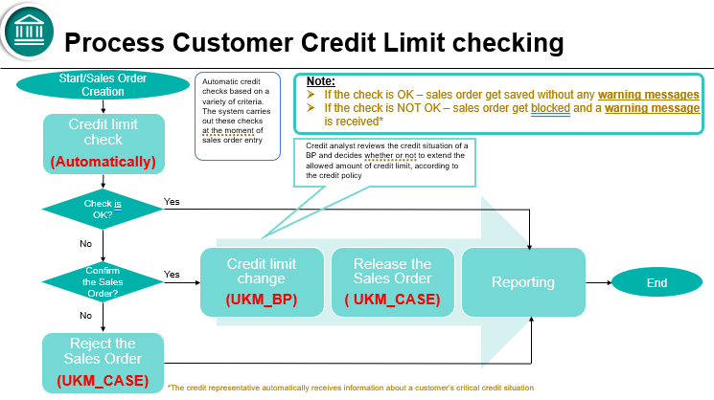

Main roles:
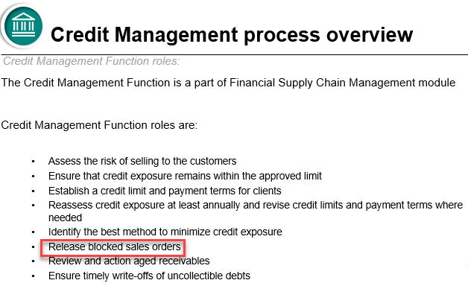
So, if Sales order was blocked, there are 3 possible approaches:
- To reject this SO
- To release this SO (thought there can be some issues)
- To fix all issues and after that to Check this SO again
If Sales order is blocked, manual activity is required, there is NO any automatic solution to unblock Sales order (!)
If, for example, Incoming payment is posted -> Credit exposure will be updated automatically accordingly but blocked SO must be checked / or released manually by UKM_CASE transaction.
If applicable, you can select the list of relevant SOs and release all of them by one run.

SAP menu
The following transactions can be used:
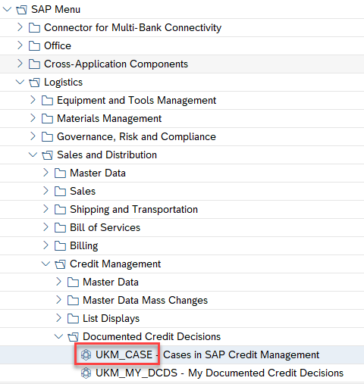
Or FI area:
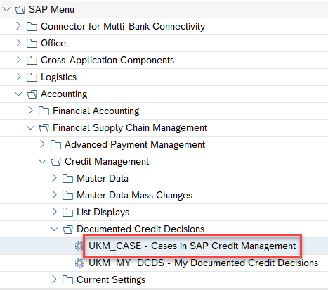

Confirm the Sales order: 3 cases

General info
Transaction UKM_CASE can be used to check the reason why Sales order was blocked, etc.
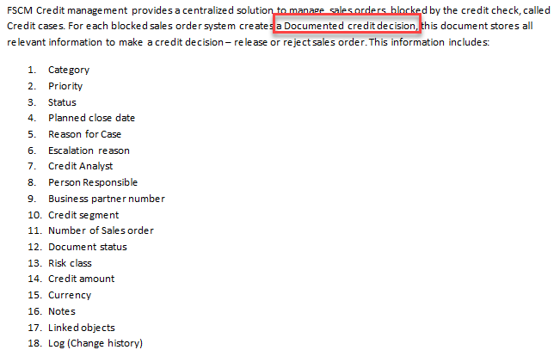

Case 1: Release the Sales order
Project Blueprint documentation:
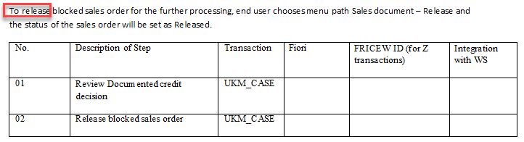
Sales Order status is blocked:
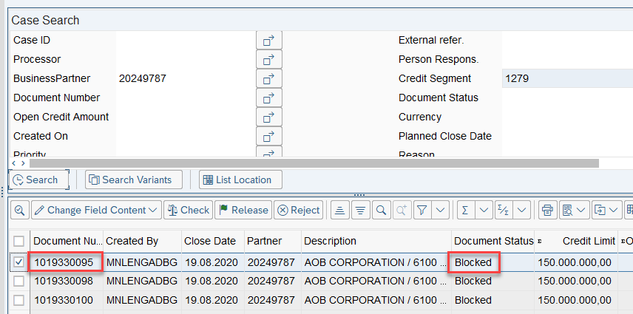
VA03 transaction status:
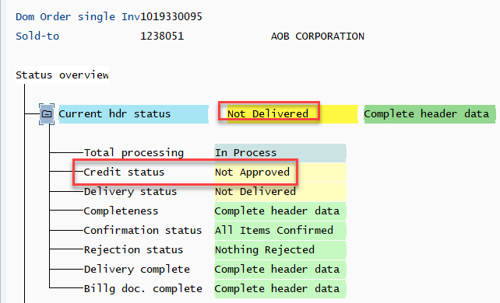
Let’s release this SO:
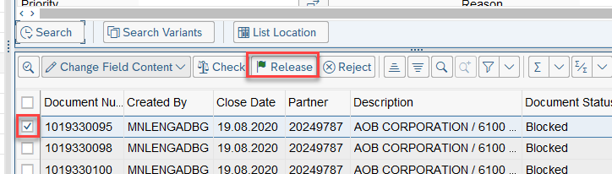
Remark: if applicable you can select the list of SOs and release all of them by one run.
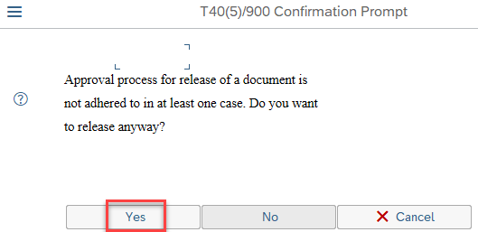
After that:
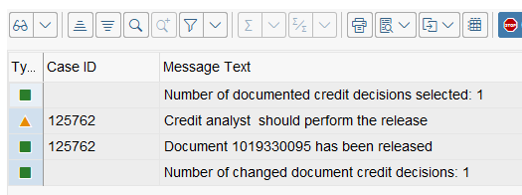

Status after that in VA03 transaction: 
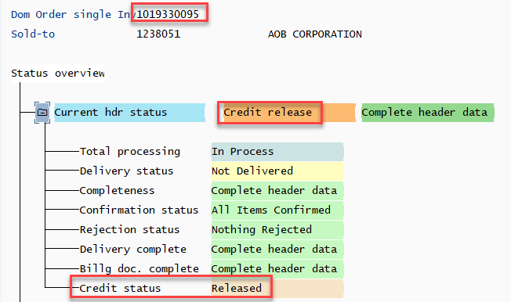
So, this SO is available now for further activities (goods issue, invoice issue, etc.)

Case 2: Reject the Sales order
Project Blueprint documentation
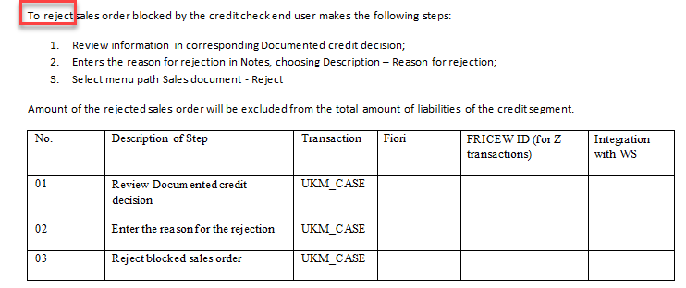
SO status is blocked:
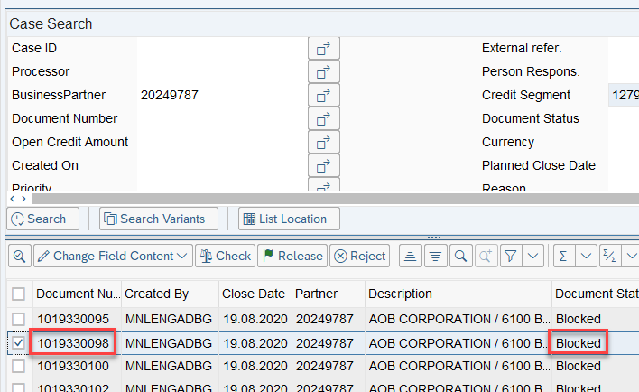
VA03 transaction status:
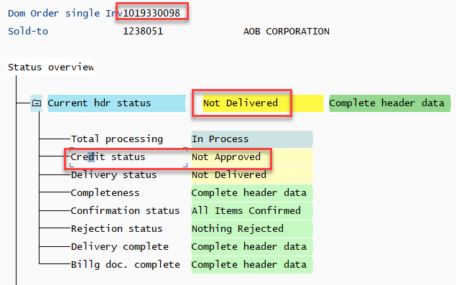
Let’s reject this SO.
First, put the reason for rejection:
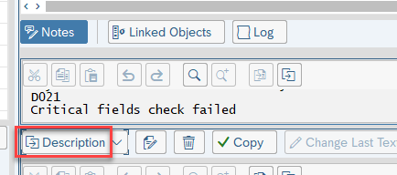
After that:
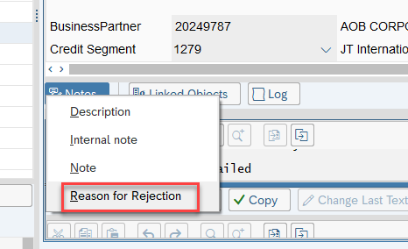
After that:
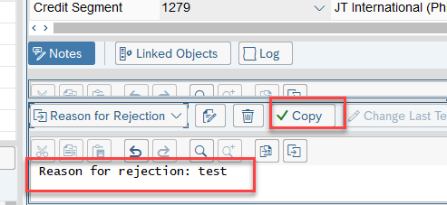
After that:
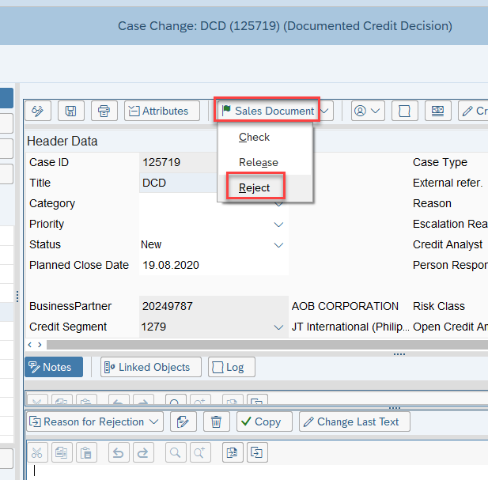
After that:
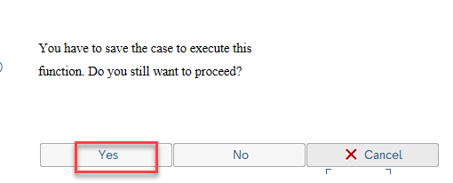
After that choice the reason for reject (for example, 03) and SO is rejected:
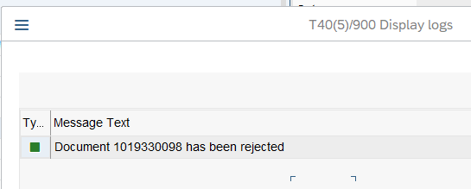
Status in VA03 after rejection:
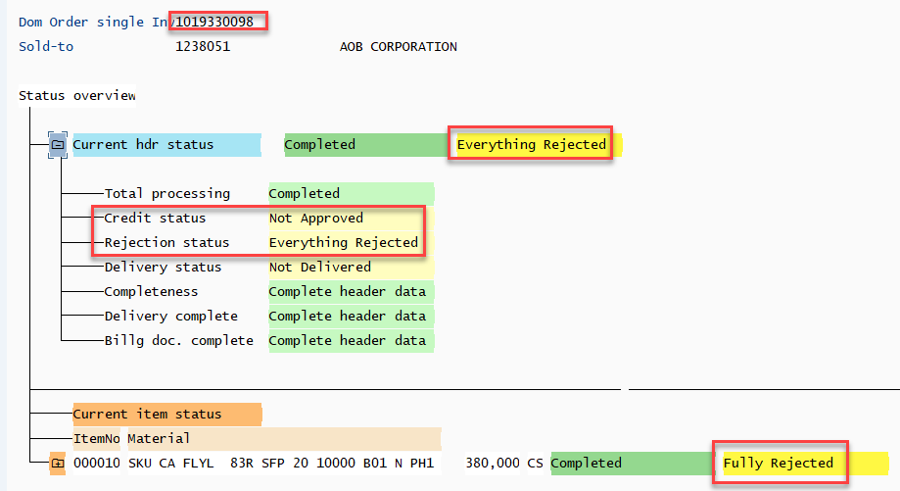
SO is rejected -> NO further activities are possible after that with this SO (!)

Case 3: fix the issues and check Sales order after that
Sales order was blocked, let’s Check it:
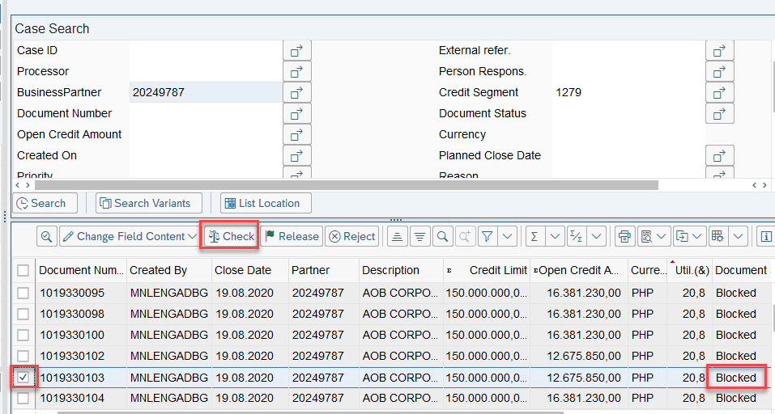
Results:
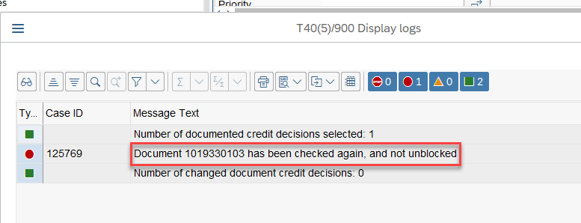
You can check Log directly in UKM_CASE transaction:
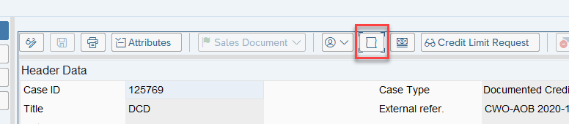
Or you can check SO by VA02 transaction accordingly.
Let’s check Sales order by VA02 transaction, for example:
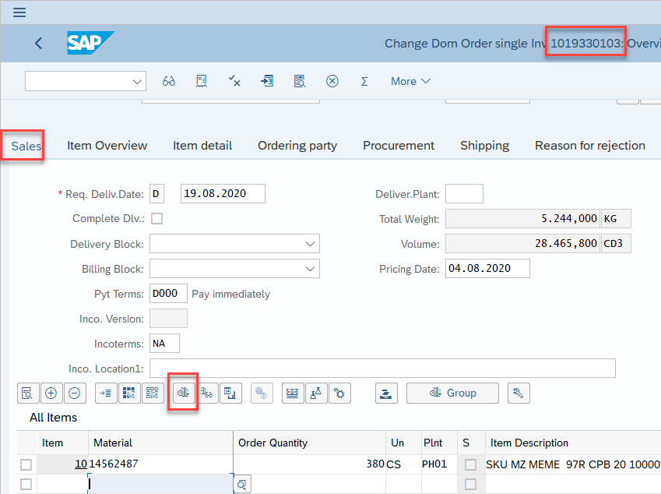
Results:
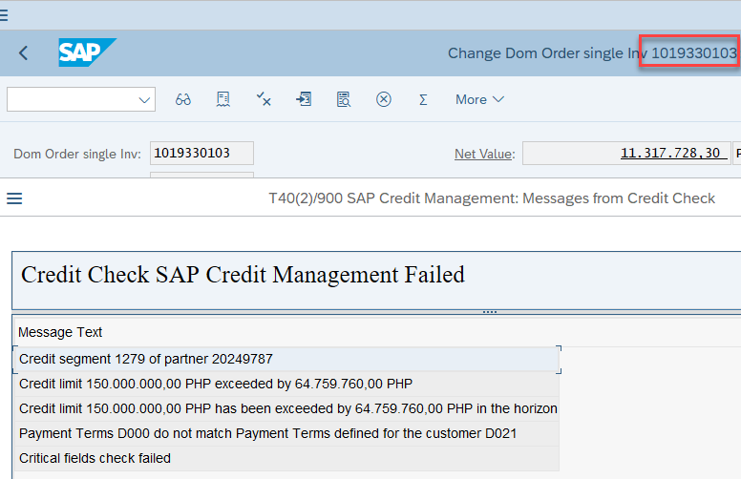
There are 2 issues for this SO:
- Credit limit exceeded
- Payment term do not match.
There are 3 variants here:
- To reject SO
- To release SO (thought there are these issues)
- Check / correct these 2 issues and Check this SO after that again.
Let’s check Credit exposure, post some Customer Payments, and check Credit exposure again after that:
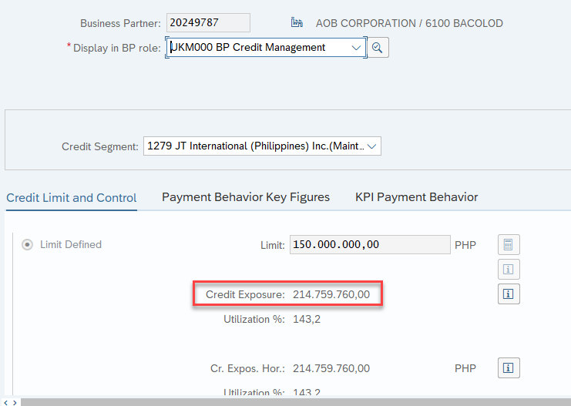
Utilization is not OK -> it is more that 100% (!)
Details:
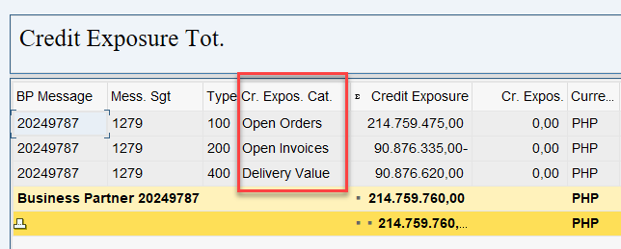
Payments (Down payments received) were posted, and Credit limit was updated automatically after that, Credit exposure is OK, it is with minus now:
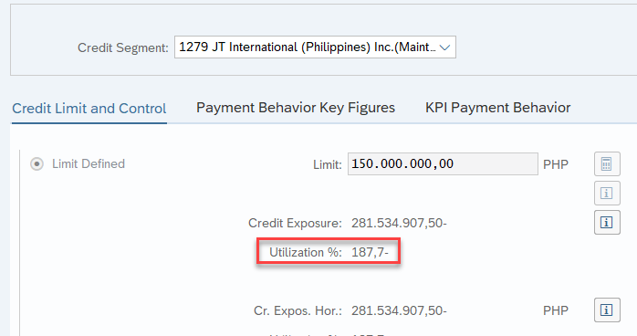
Let’s Check this Sales order again:

It is still not unblocked because there is still 2nd issue with Payment term (VA02 transaction check):
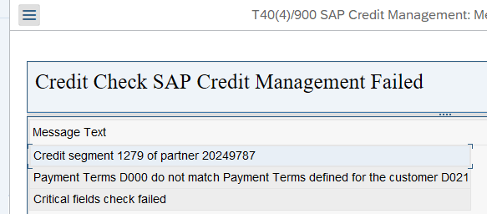
Let’s change Payment term from D000 to D021 for this SO, save and try to check this Sales order again.
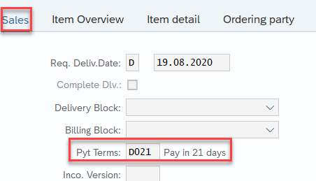

Check again:

Checking results are finally OK now -> further sales activities can be done accordingly (goods issue, invoice issue, etc.):
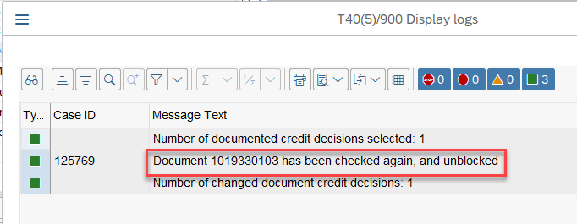
If you try to Check this Sales order again:
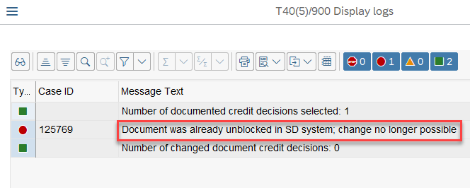
Transaction VA03, check Sales order status: 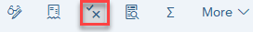
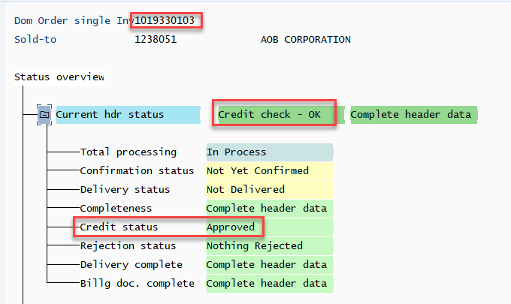
Non-checked SO to compare:
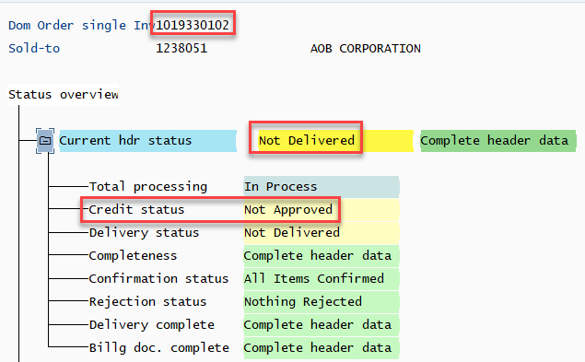
SUMMARY:
- we checked which exact issues were determined for the selected SO
- we fixed these issues (a) Incoming payments were posted -> credit limit is OK, b) Payment term was set to the correct one)
- we check this SO -> after issues fixing checking is OK -> Sales order is available for further activities

